MUHOROR HC III FACILITY
S/N | Name of Facility | Picture
1 | Muhoror HC III Facility | 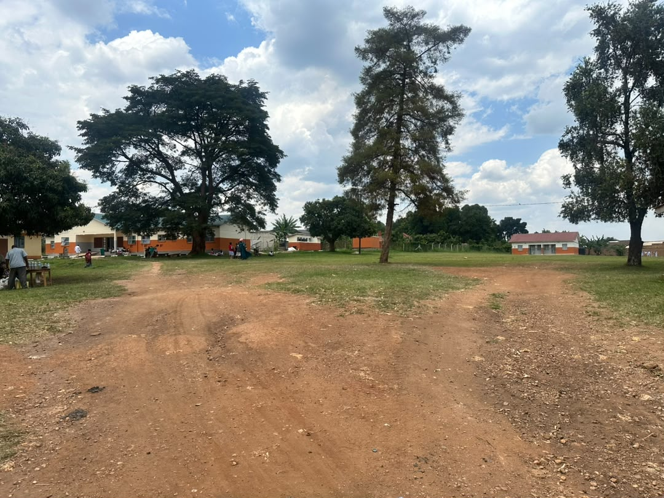
2 | Muhoror HC III Facility | 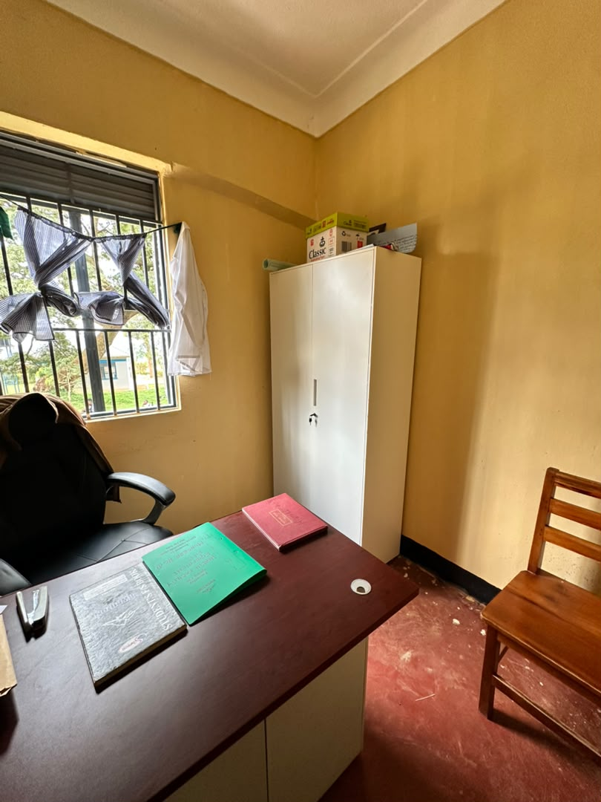
3 | Muhoror HC III Facility | 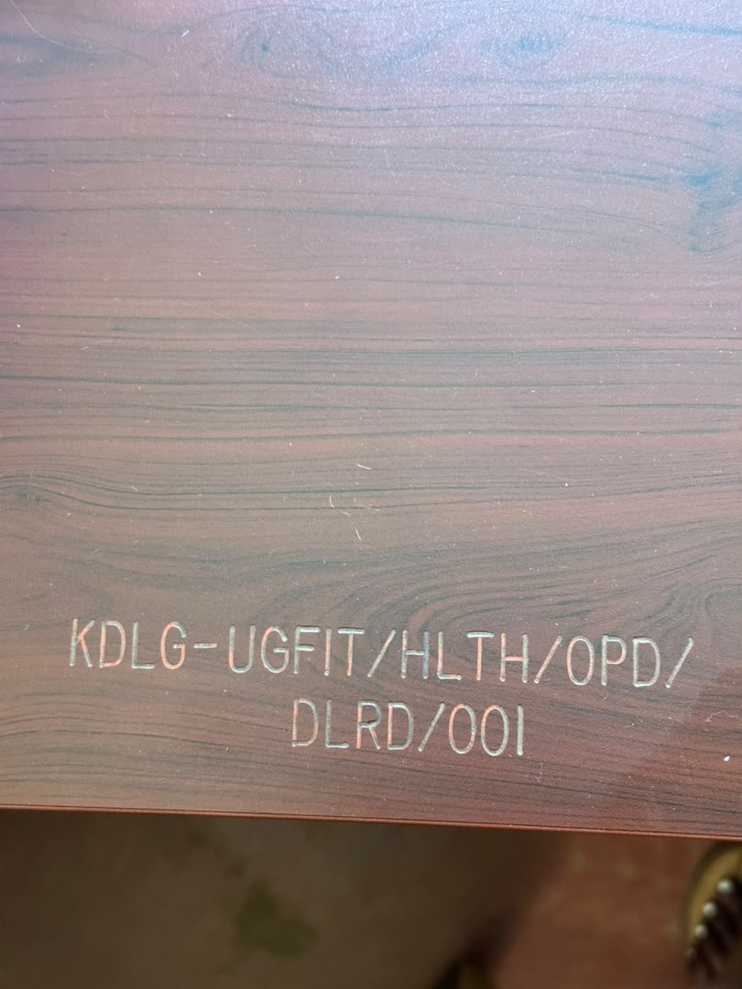
4 | Muhoror HC III Facility | 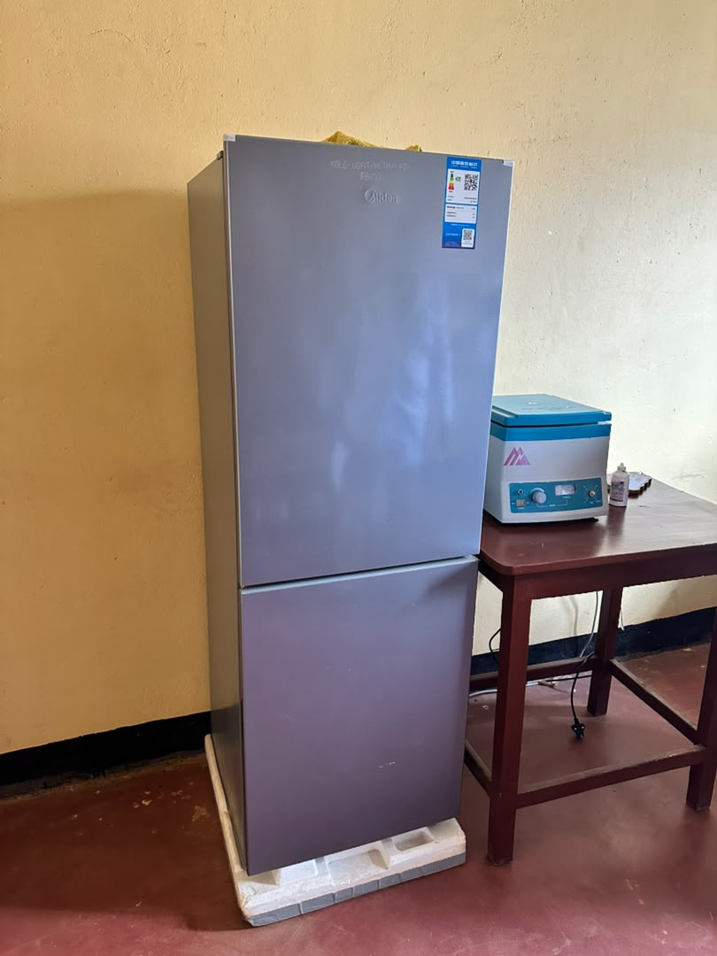
5 | Muhoror HC III Facility | 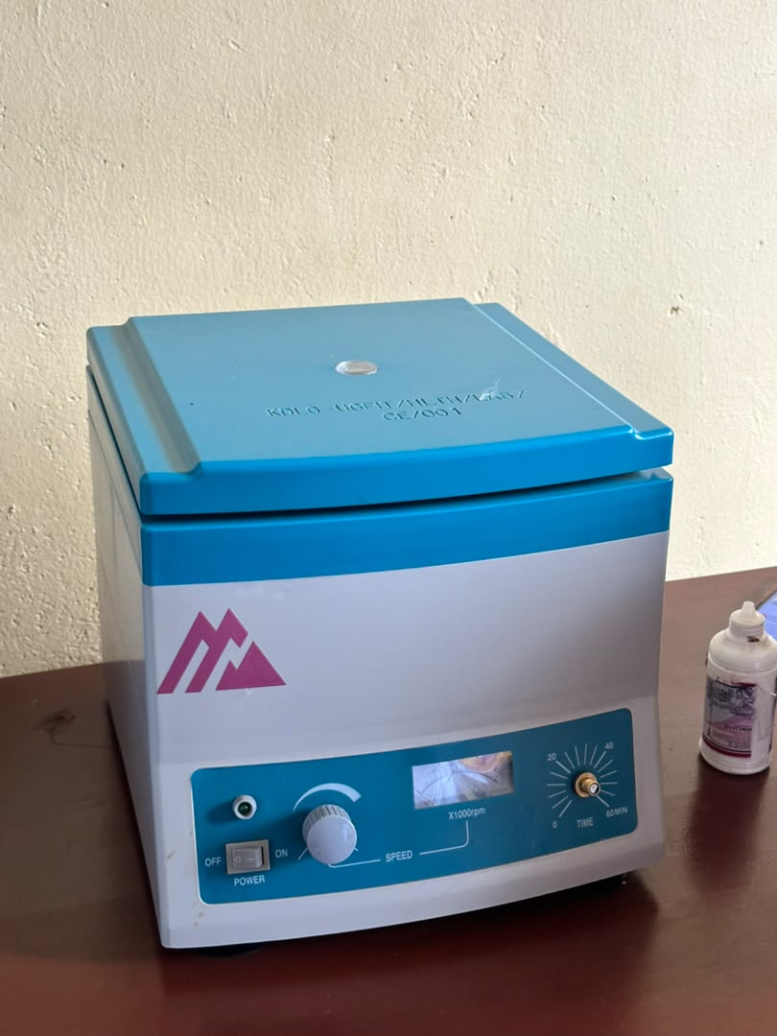
6 | Muhoror HC III Facility | 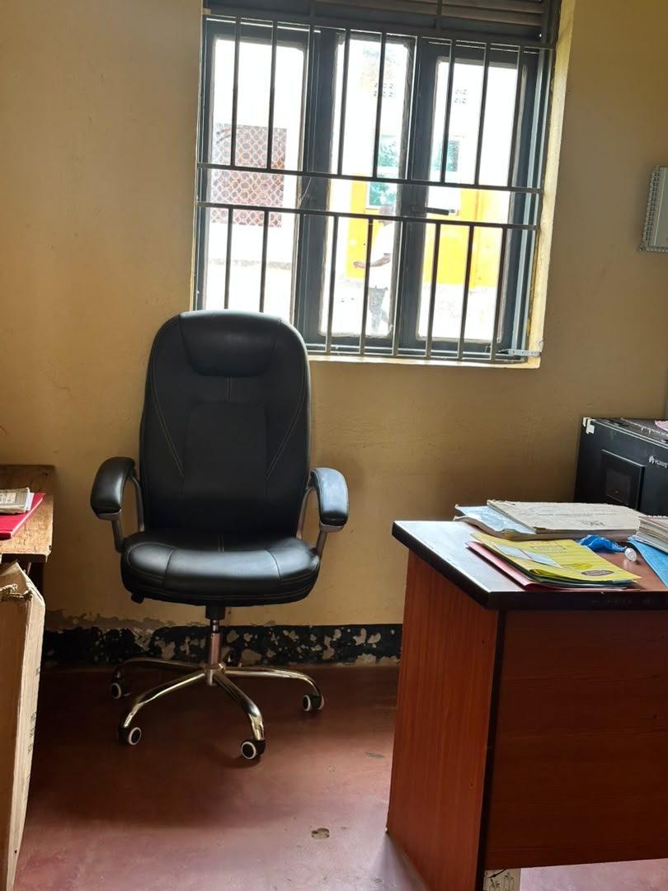
7 | Muhoror HC III Facility | 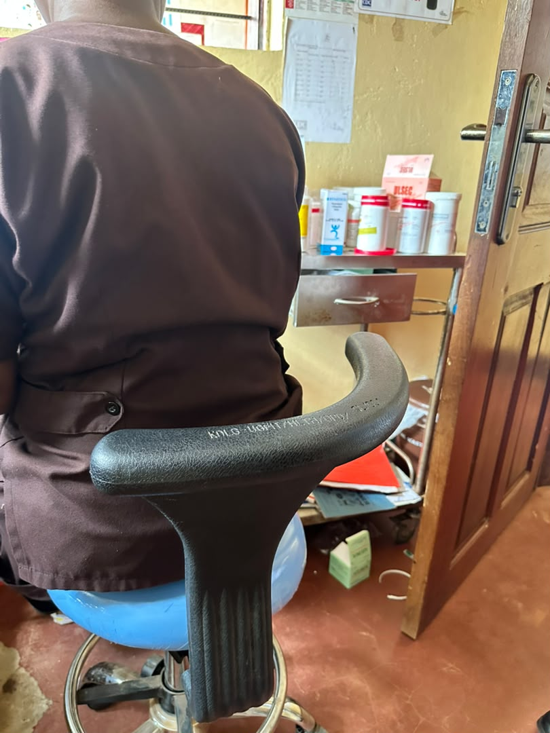
8 | Muhoror HC III Facility | 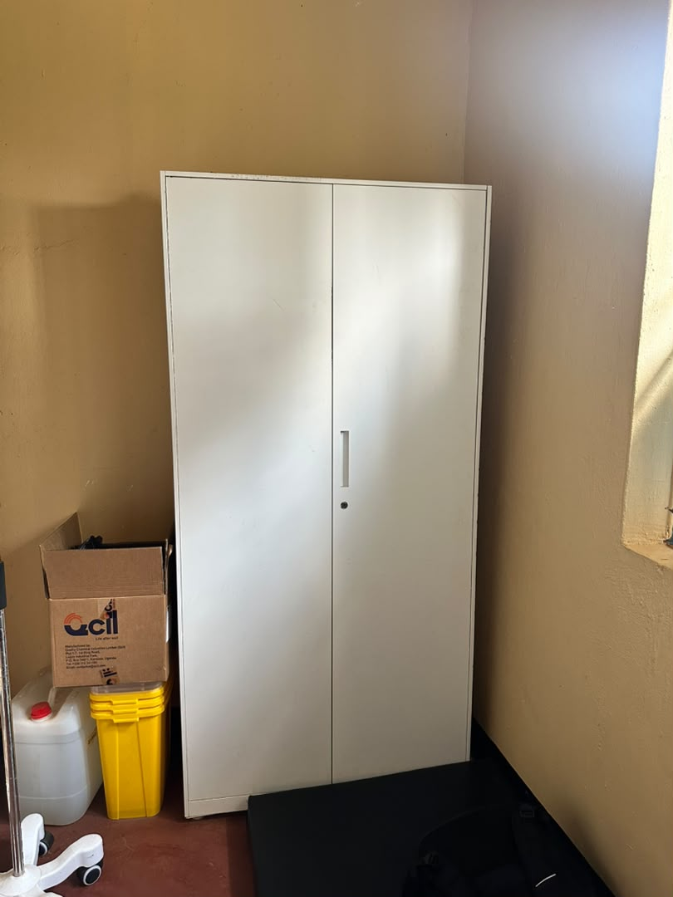
9 | Muhoror HC III Facility | 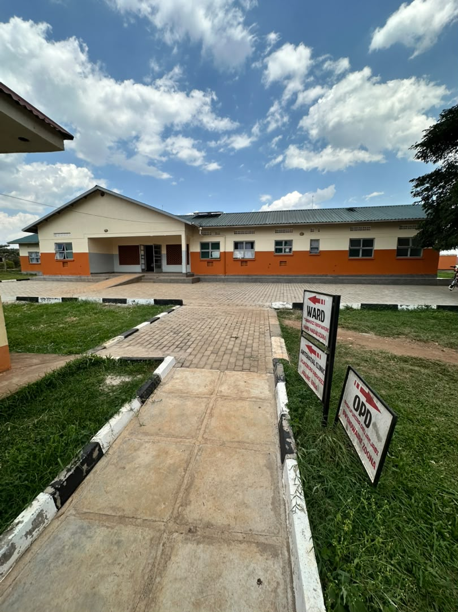
10 | Muhoror HC III Facility | 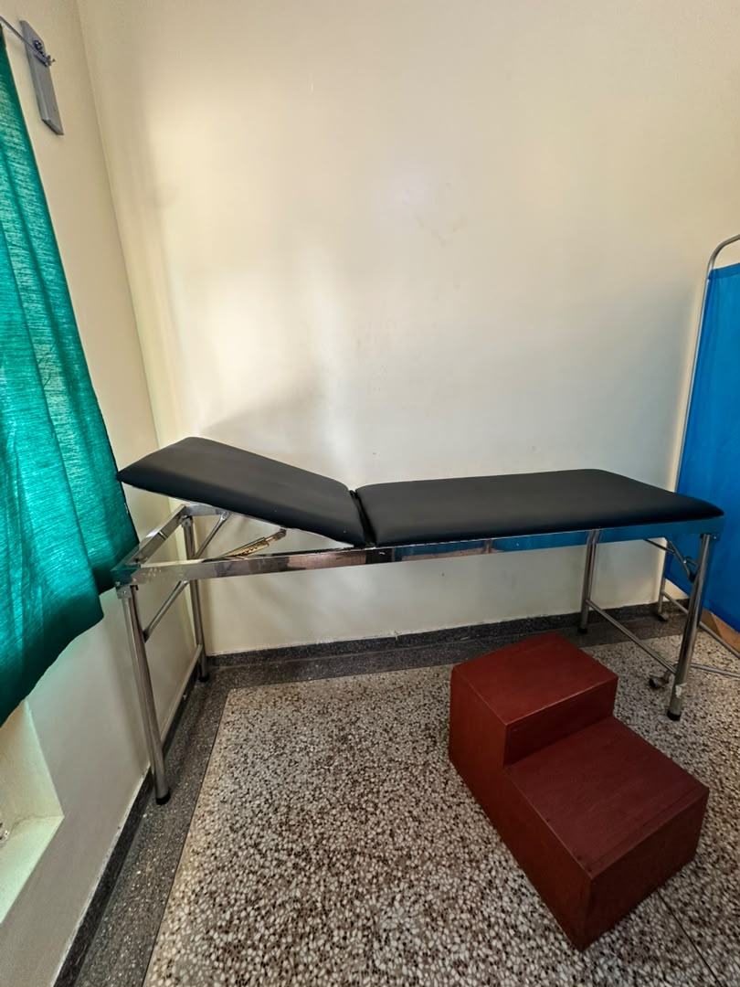
11 | Muhoror HC III Facility | 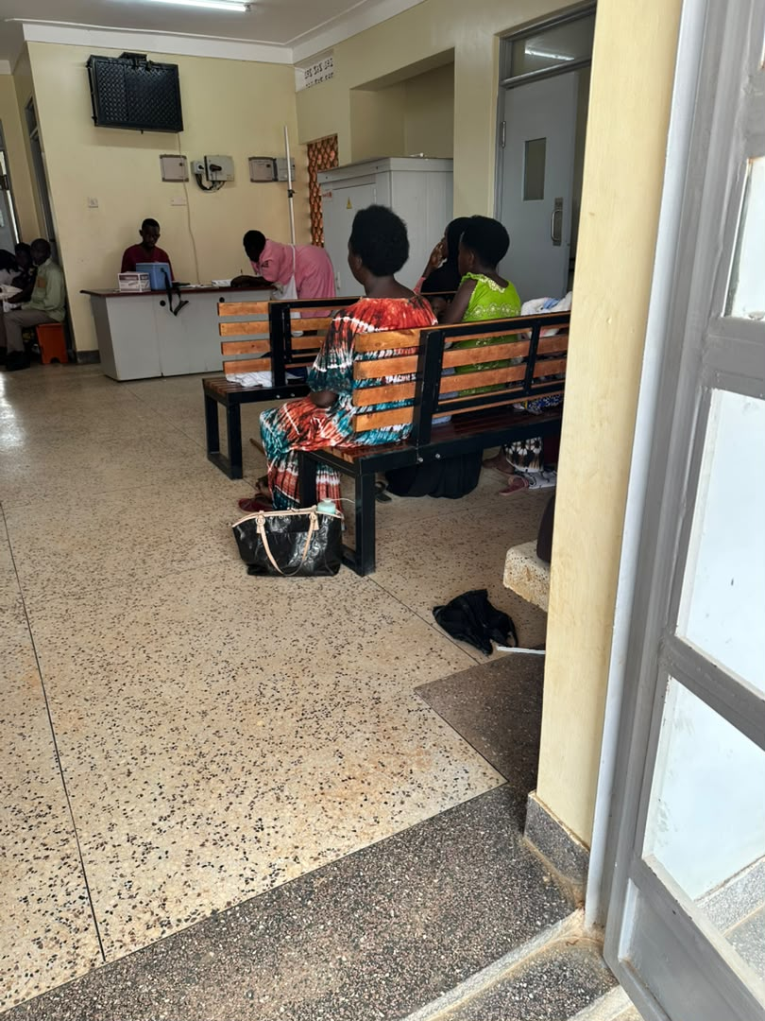
12 | Muhoror HC III Facility | 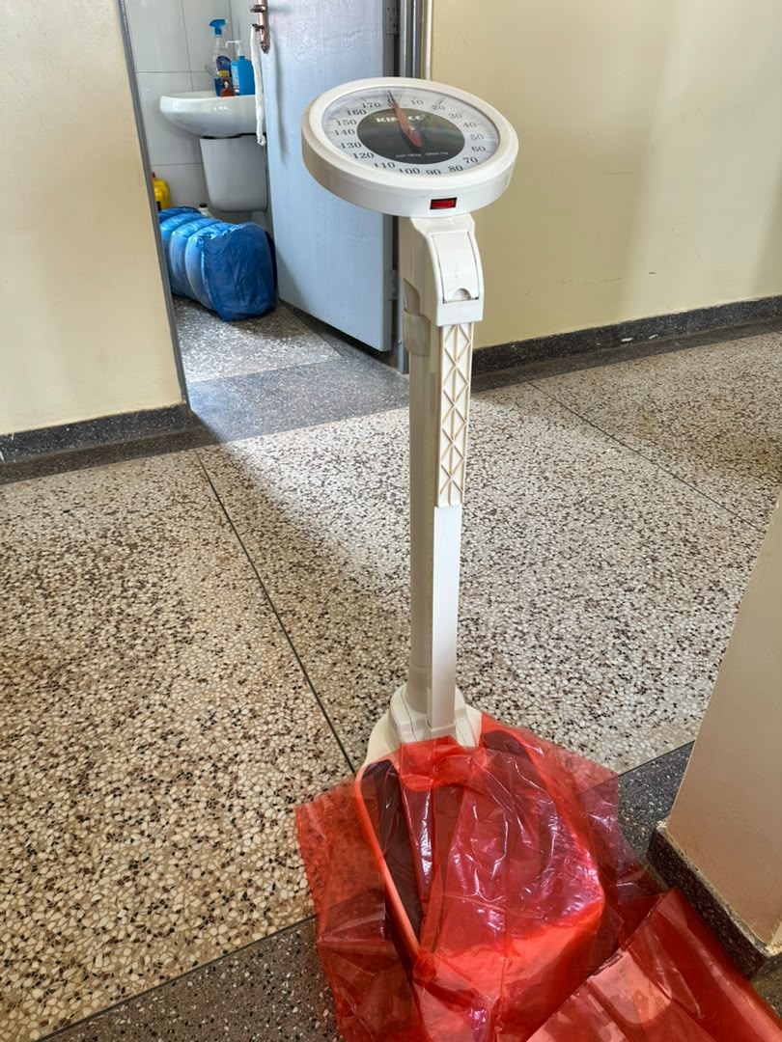
13 | Muhoror HC III Facility | 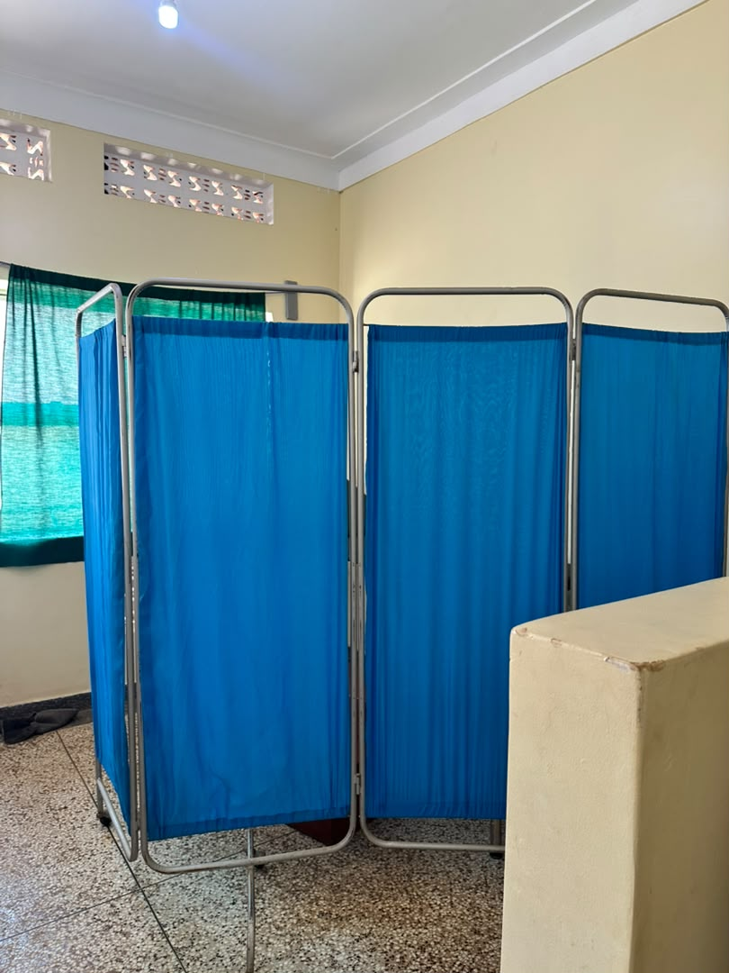
14 | Muhoror HC III Facility | 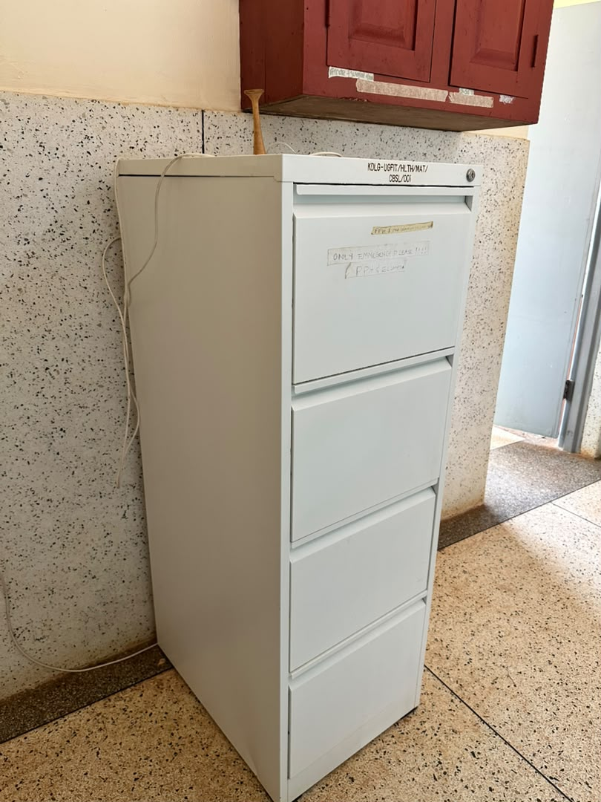
15 | Muhoror HC III Facility | 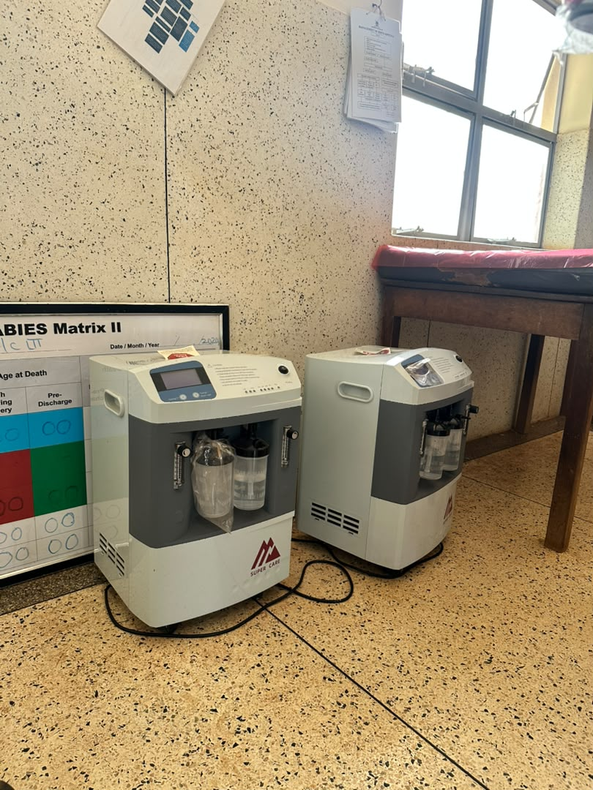
16 | Muhoror HC III Facility | 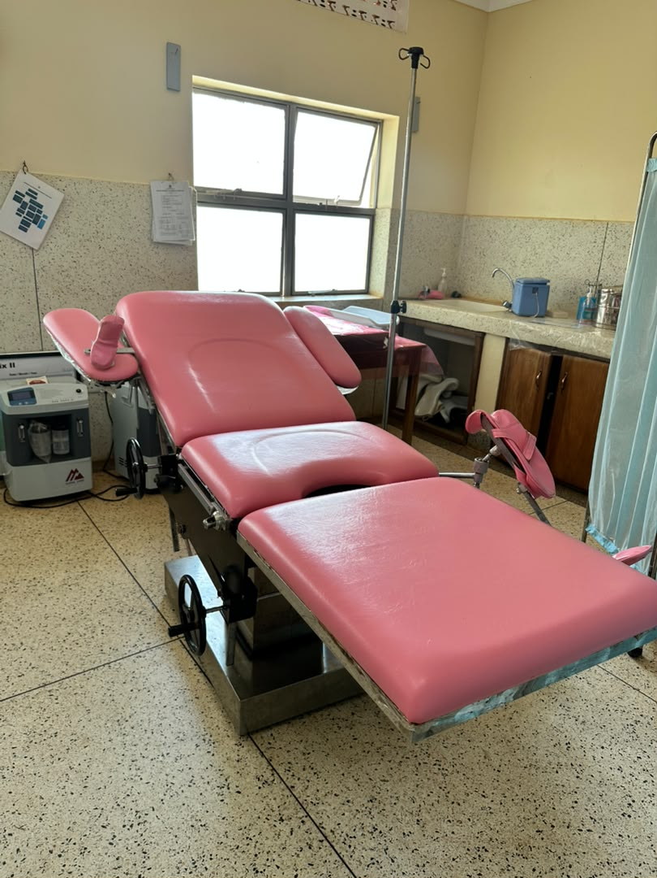
17 | Muhoror HC III Facility | 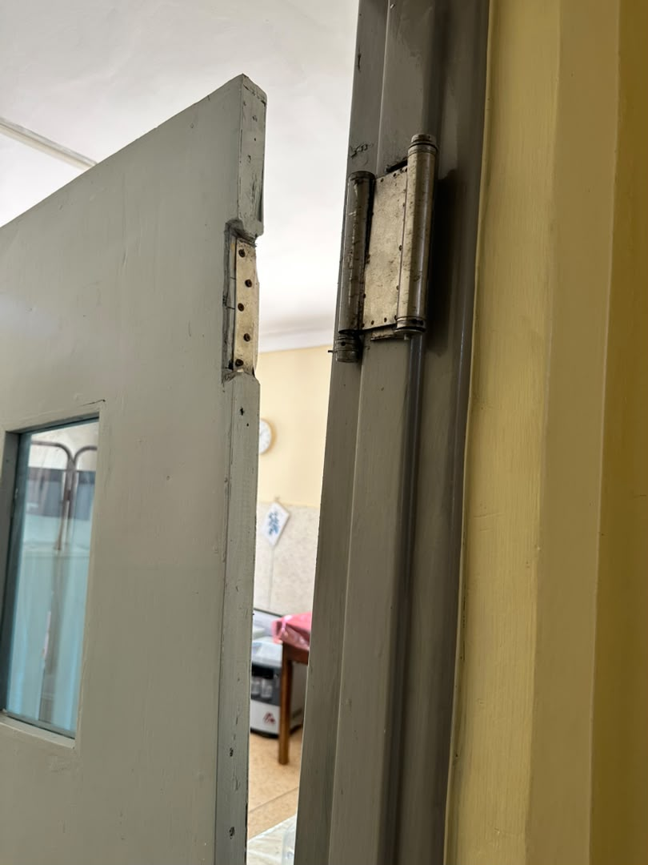
18 | Muhoror HC III Facility | 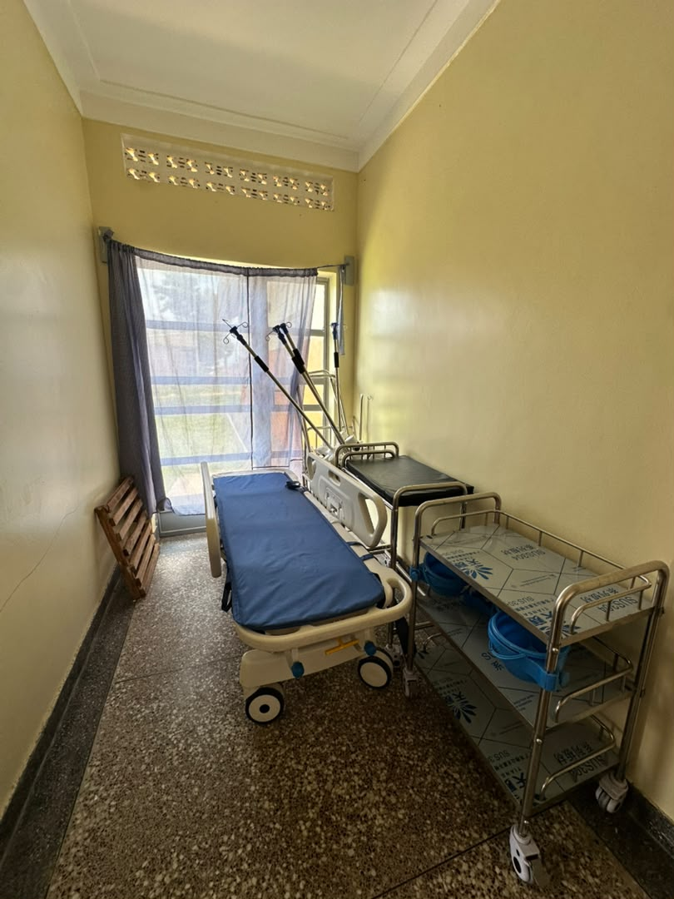
19 | Muhoror HC III Facility | 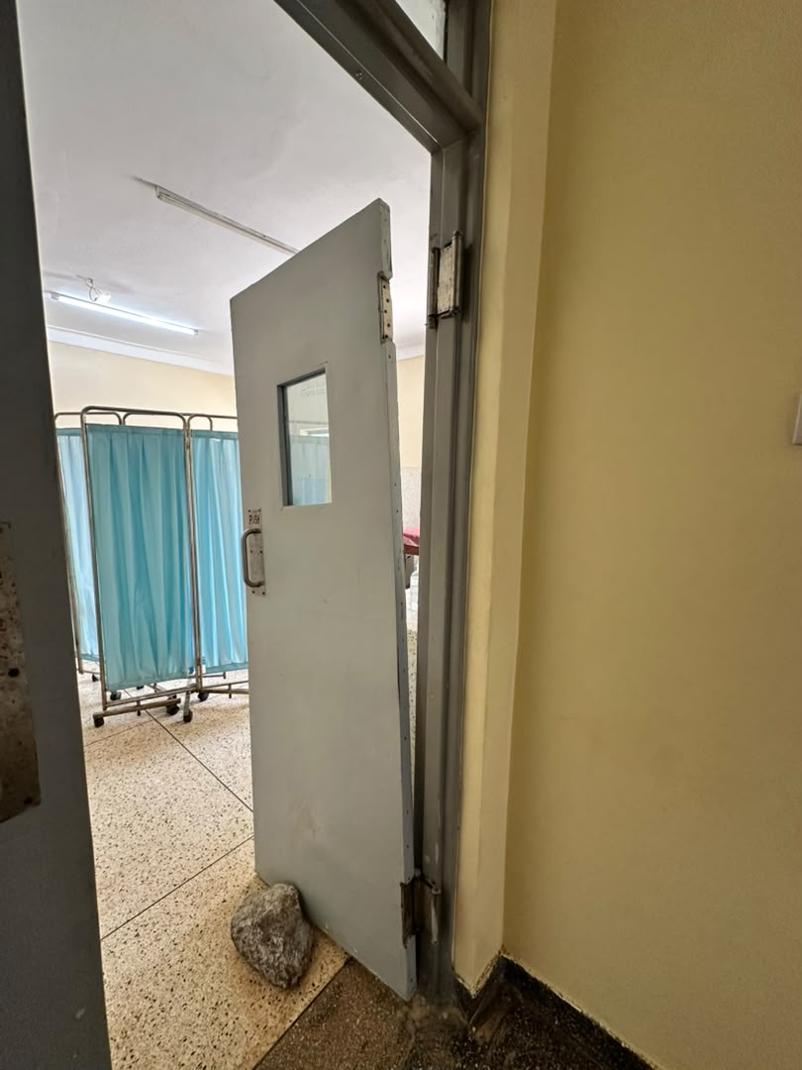
20 | Muhoror HC III Facility | 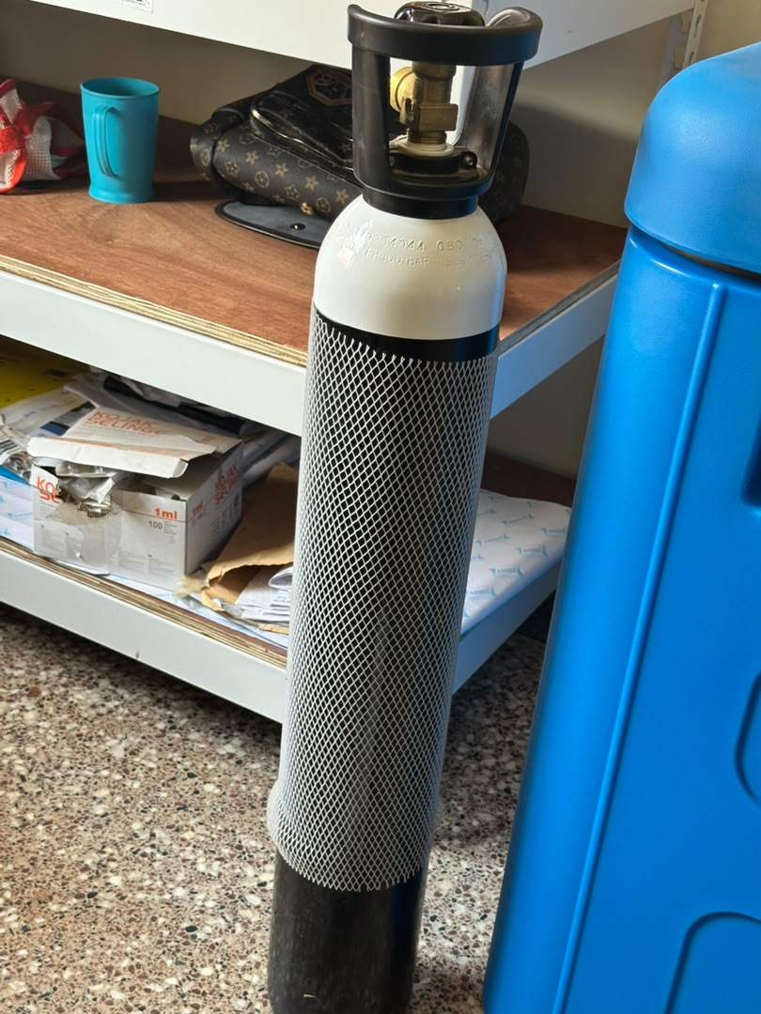
21 | Muhoror HC III Facility | 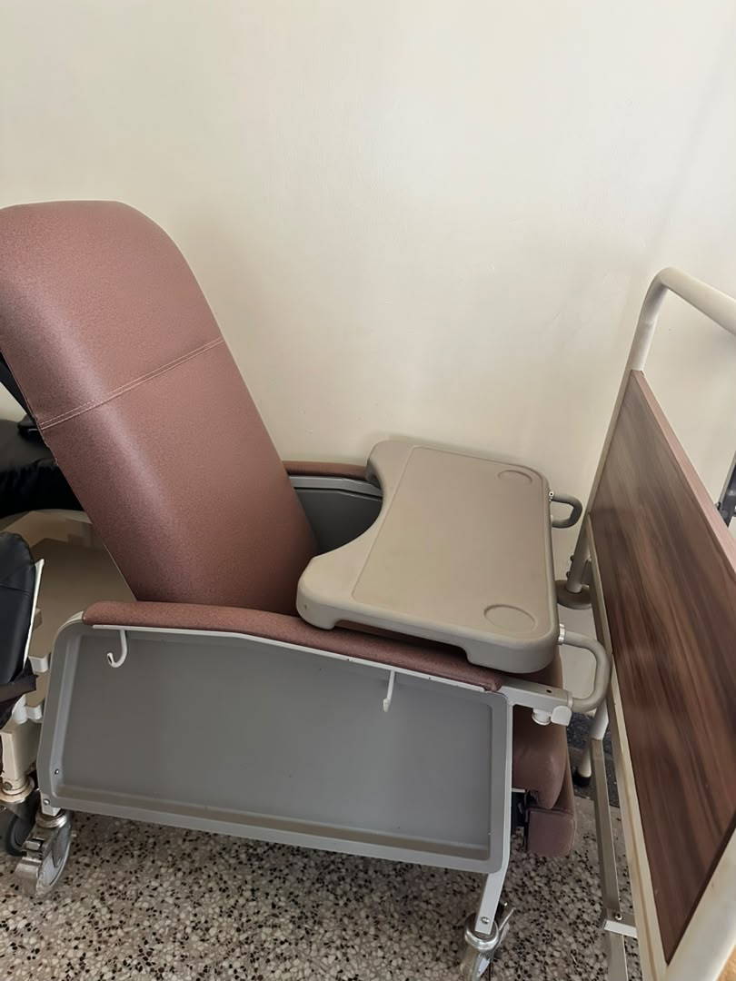
22 | Muhoror HC III Facility | 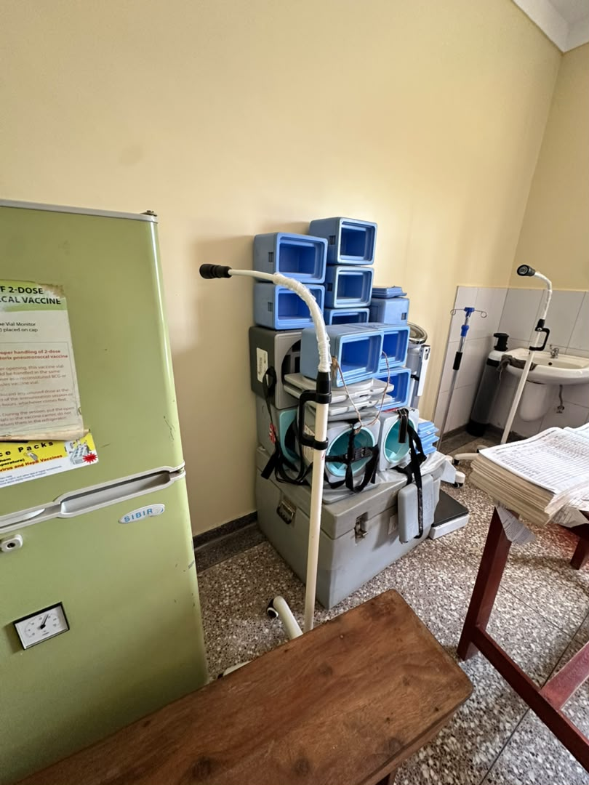
23 | Muhoror HC III Facility | 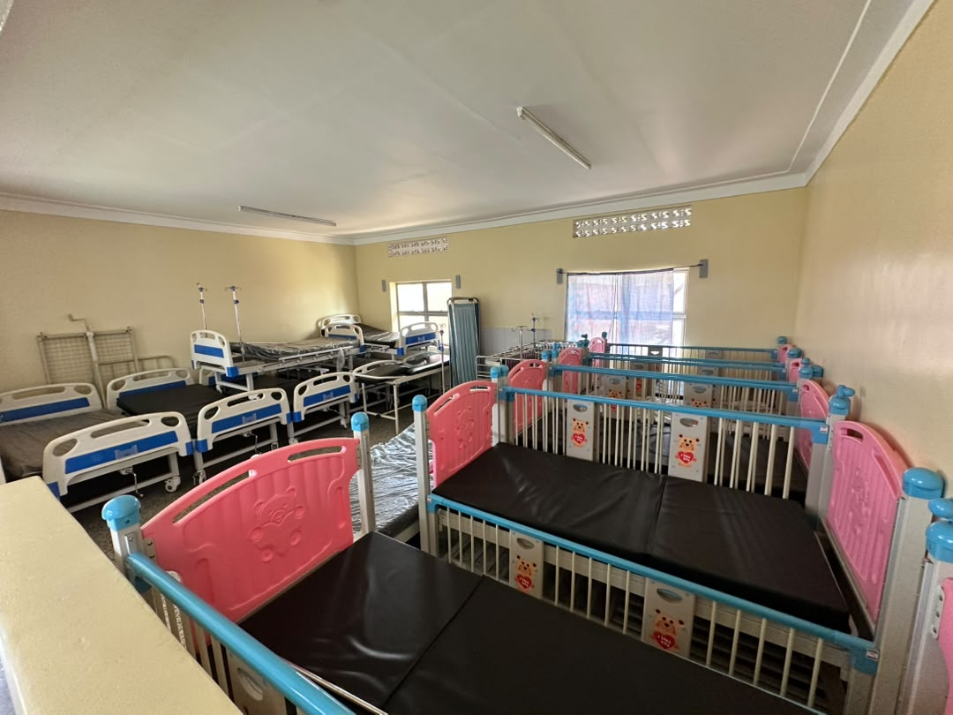
24 | Muhoror HC III Facility | 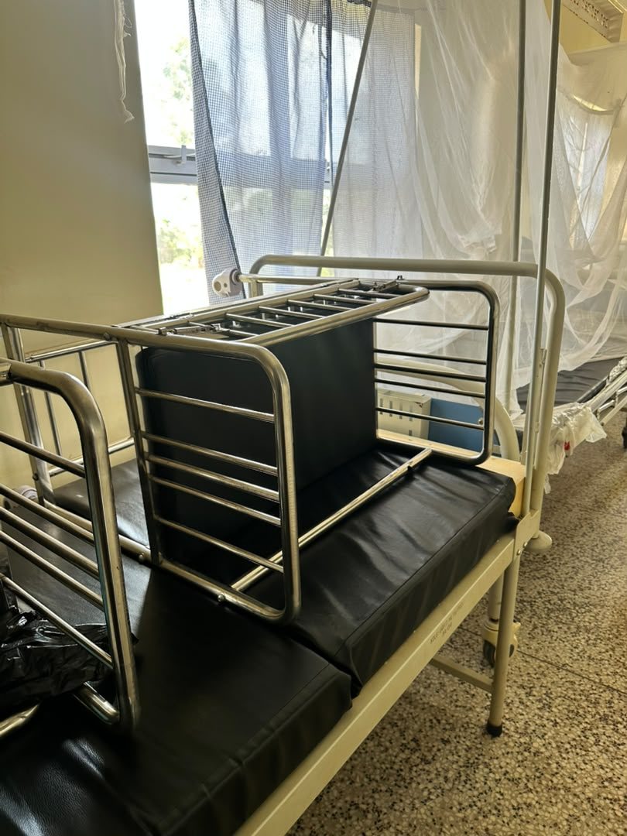
25 | Muhoror HC III Facility | 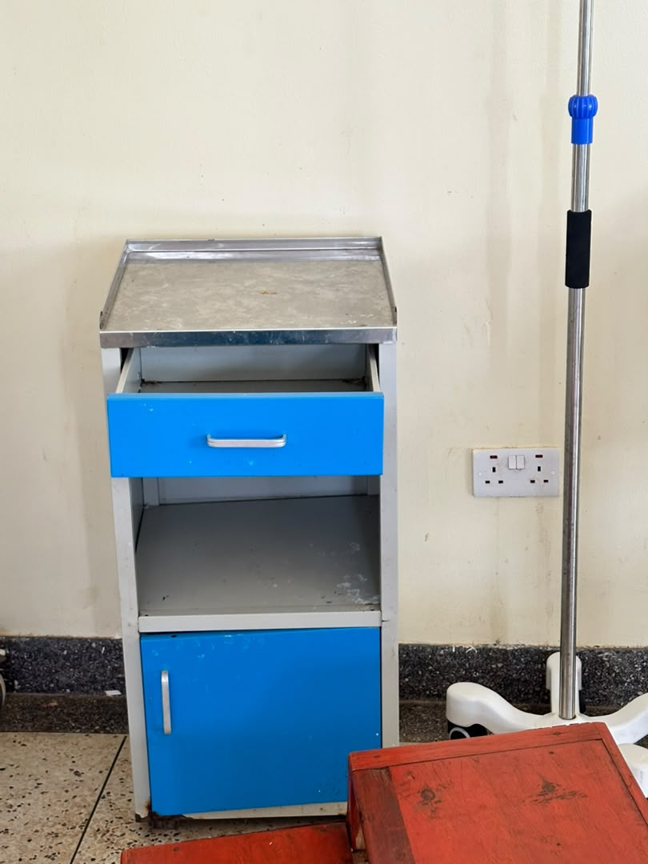
26 | Muhoror HC III Facility | 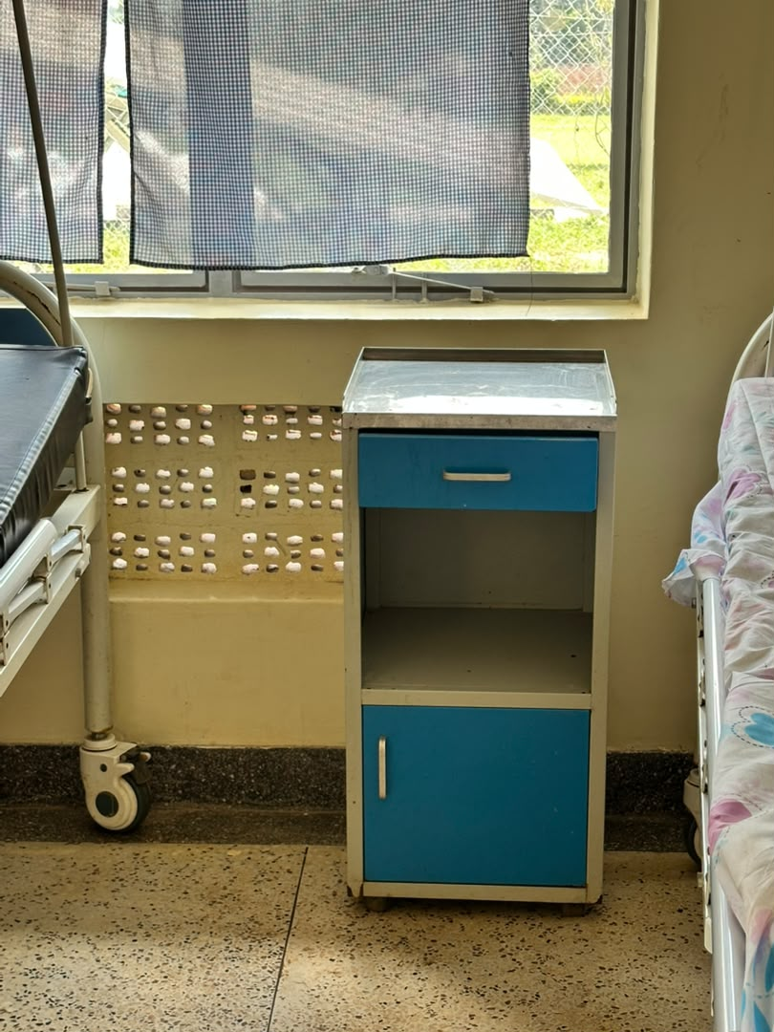
27 | Muhoror HC III Facility | 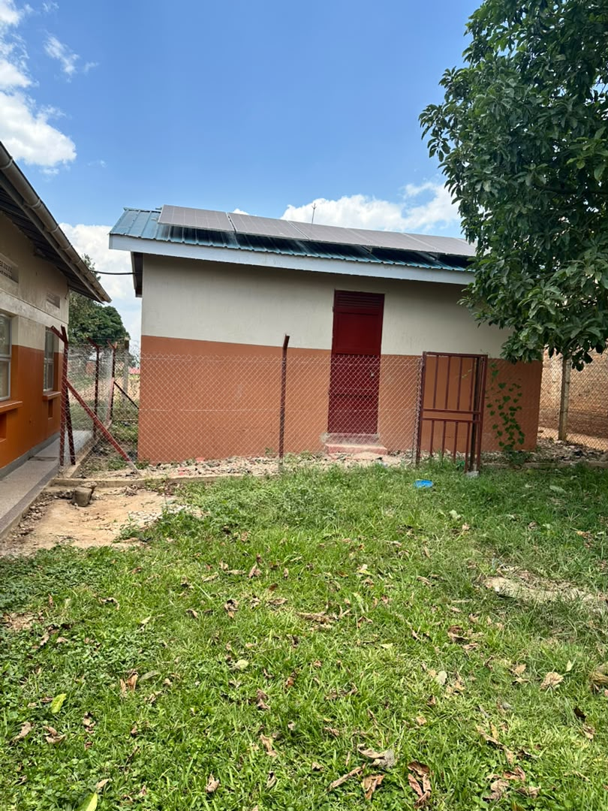
28 | Muhoror HC III Facility | 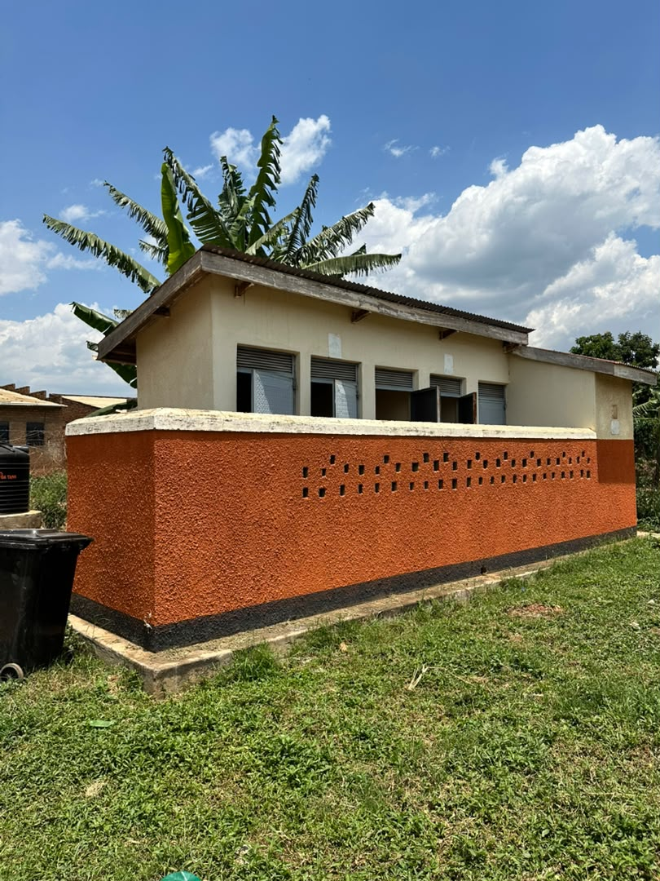
29 | Muhoror HC III Facility | 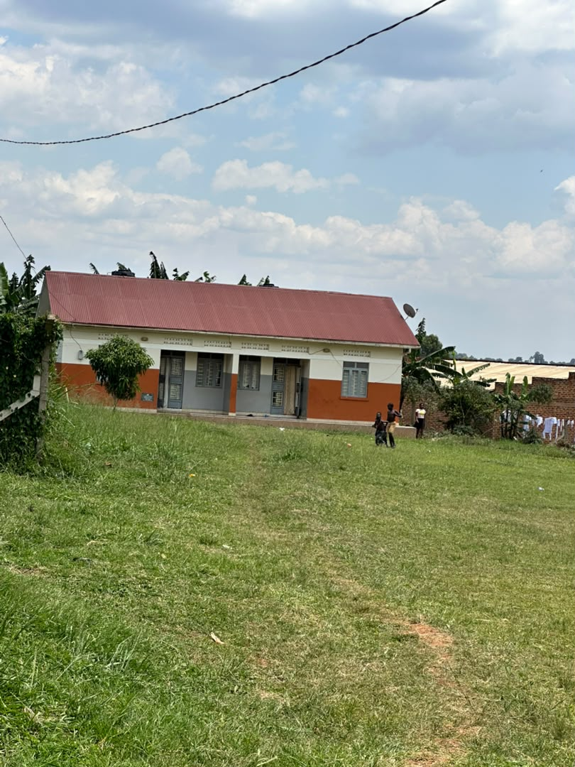
30 | Muhoror HC III Facility | 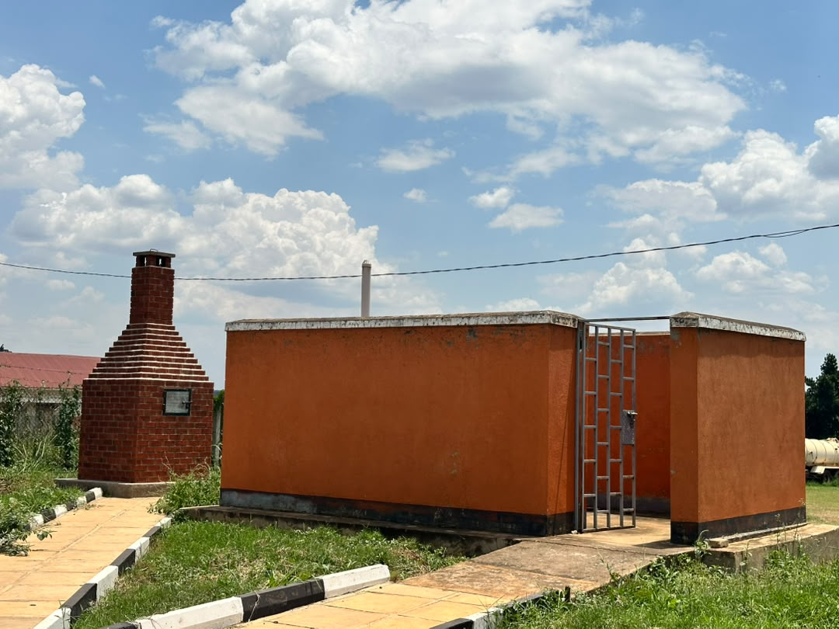
31 | Muhoror HC III Facility | 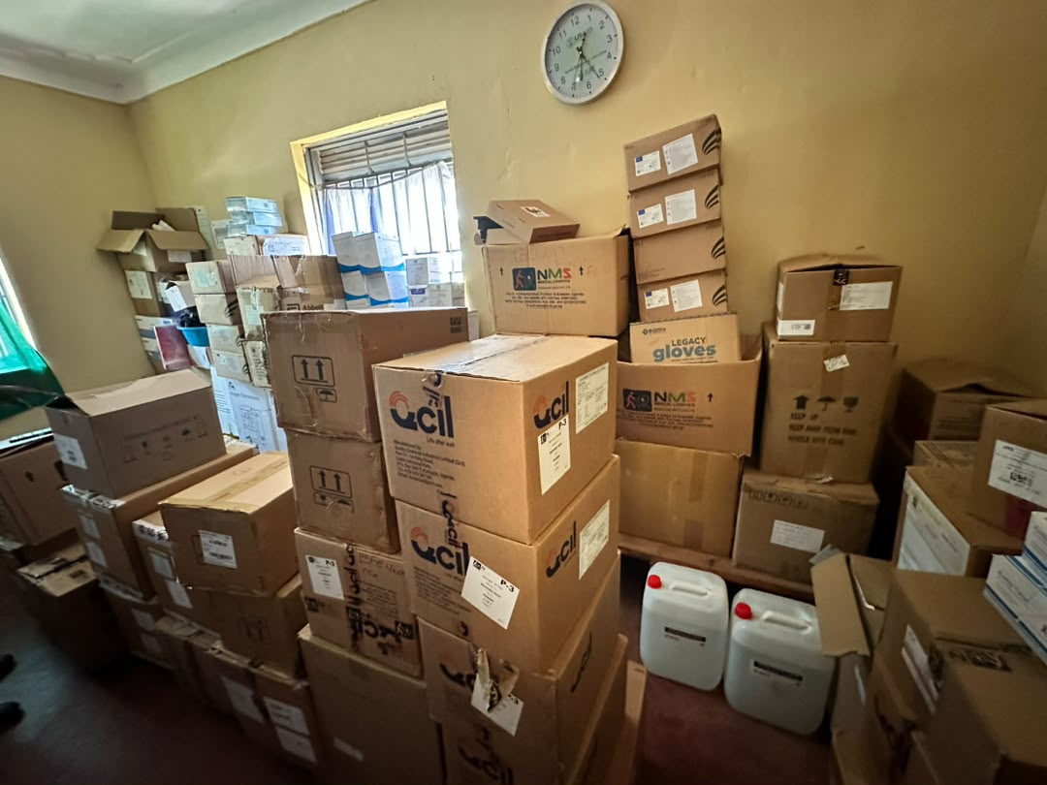
32 | Muhoror HC III Facility | 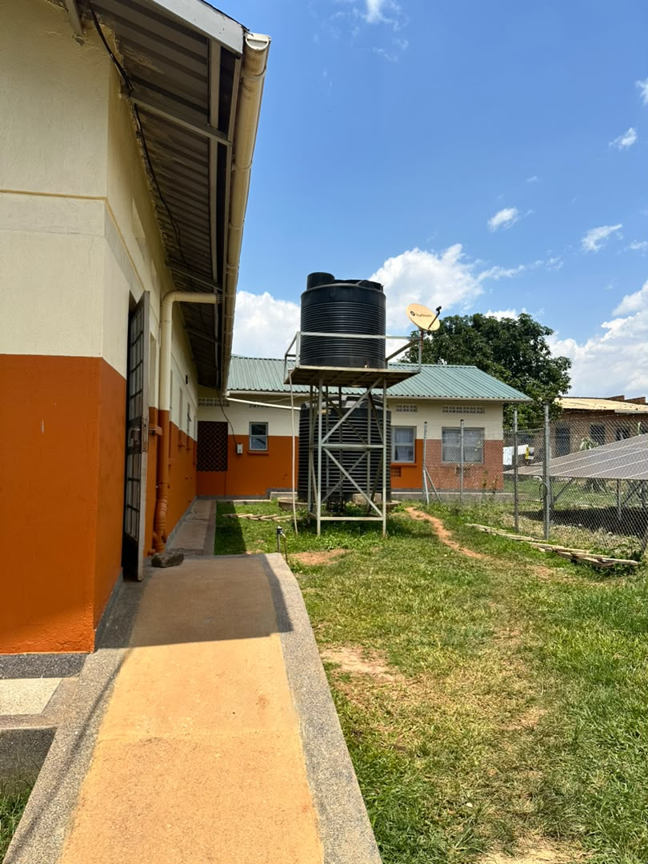
33 | Muhoror HC III Facility | 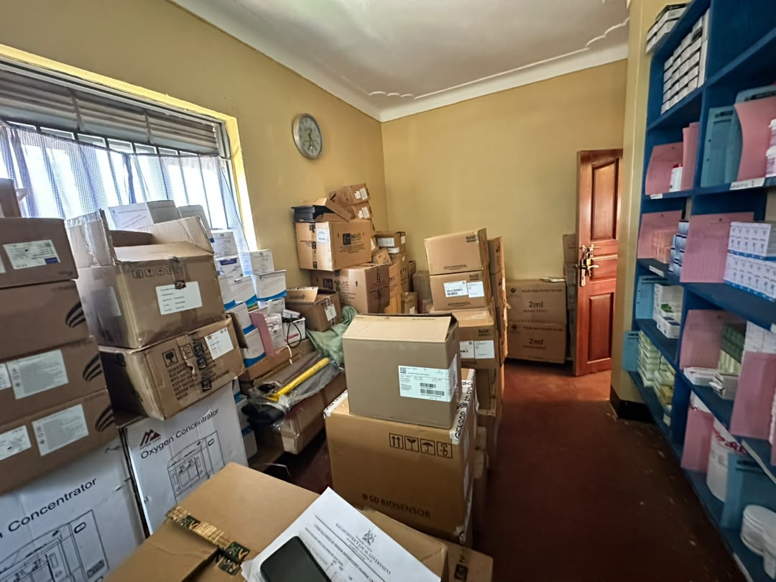
34 | Muhoror HC III Facility | 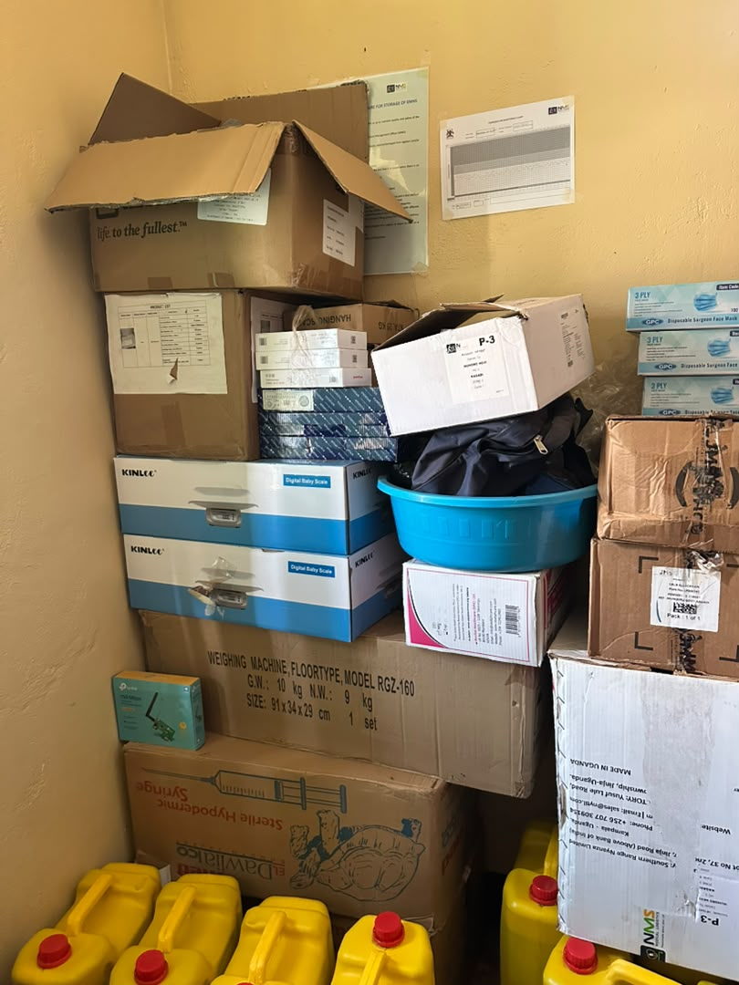
35 | Muhoror HC III Facility | 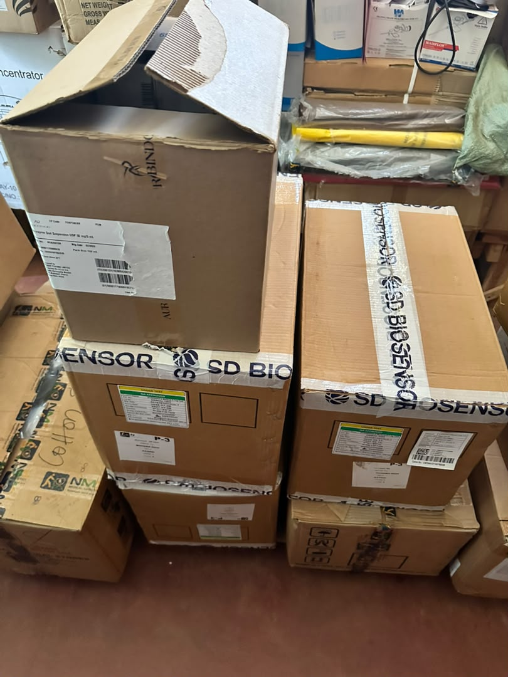
36 | Muhoror HC III Facility | 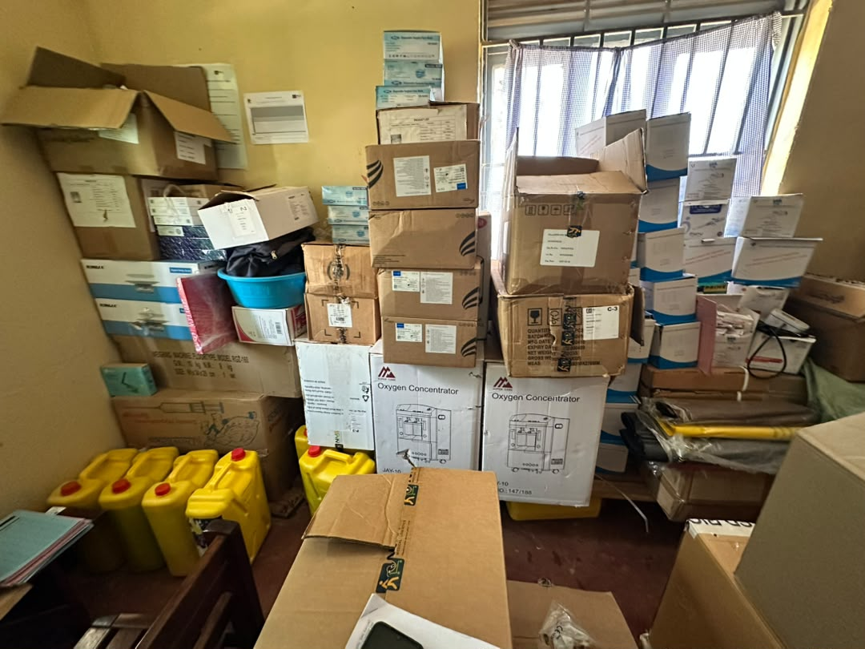
37 | Muhoror HC III Facility | 